QUEEN OF THE RING

INV ITE S Y OU TO O UR

2nd ANNUAL BOXING CUP

in HUNGARY, 9730 Kőszeg, Deák Ferenc utca 6

18 March to 23 March 2018

THIS IS A BOXING TOURNAMENT FOR SCHOOLGIRLS
&
JUNIOR & YOUTH GIRLS
&
ELITE WOMEN

Hungarian Boxing Association and Fitt-Box Kőszeg are delighted to invite you to our 2nd Annual “Queen Of The Ring Boxing Cup 2018". This is an International Boxing tournament for schoolgirls, junior and youth girls and elite women.

It would be great if you and your team were part of it. If you have any further
questions, please do not hesitate to email me.

Yours in boxing,

András Gáll
Hungarian Boxing Association International director
hungarian@boxing.hu
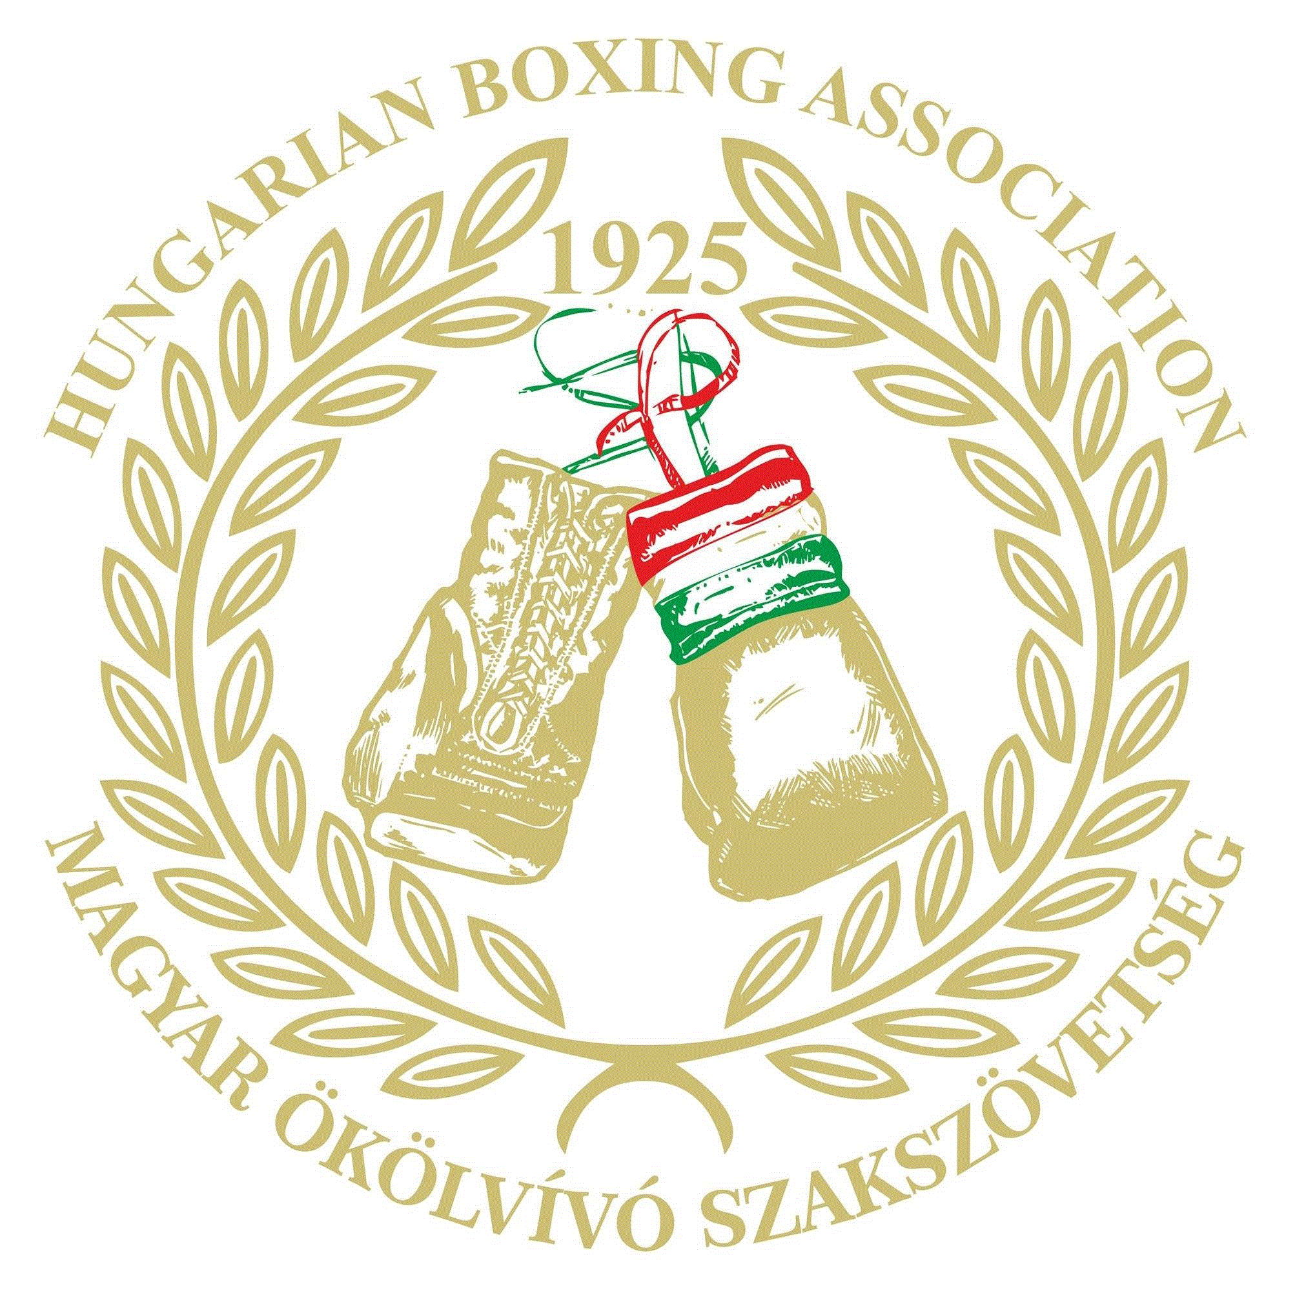


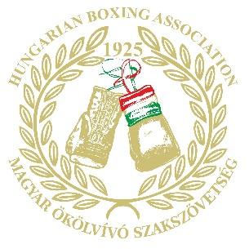
- OFFICIAL TITLE OF EVENT
Queen of the Ring

2. EVENT PERIOD
Competition Period March 18 to 23, 2018
Arrivals March 18, 2018
Technical meeting March 18, 2018
General Weigh-In March 19, 2018
Official draw March 19, 2018
Departures March 23, 2018

3. COMPETITION VENUE
- Name: Béri Balogh School Gym
- Location: 9730, Kőszeg, Deák Ferenc utca 6, Hungary

5. KEY COMPETITION RULES
The Championships will be held according to AIBA Technical & Competition Rules.
Age Classification
Schoolgirl: Boxers between the ages of 13 to 14 will be eligible
Junior: Boxers between the ages of 15 to 16 will be eligible
Youth: Boxers between the ages of 17 to 18 will be eligible
Elite: Boxers between the ages of 19 to 40 will be eligible

Weight Classification
Schoolgirl: 12 categories
38 kg, 42 kg, 46 kg, 50 kg, 54 kg, 57 kg 60 kg, 63 kg, 66 kg, 70 kg, 75 kg, 75+kg

Junior: 13 categories
44 kg – 46 kg, 48 kg, 50 kg, 52 kg, 54 kg, 57 kg, 60 kg, 63 kg, 66 kg, 70 kg, 75 kg,
80 kg, 80+ kg

Youth: 10 categories
45-48, 51, 54, 57, 60, 64, 69, 75, 81, +81kg

Elite : 10 categories
45-48, 51, 54, 57, 60, 64, 69, 75, 81, +81kg

6. NUMBER OF ROUNDS
Elite & Youth :
3 rounds of 3 minutes, 1 minute rest between rounds
Junior:
3 rounds of 2 minutes, 1 minute rest between rounds
Schoolgirl:
3 rounds of 1,5 minutes, 1 minute rest between rounds

7. SCORING SYSTEM
Only AIBA 10-Point Must Scoring System will be used (Manual scoring)

8. REFEREES & JUDGES
All Referees & Judges (AIBA 1-2-3 Stars or National Level) must be mandatoryly appointed and approved by National Federations. It is recommended for each club to bring a Referee & Judge with them, but this is not essential.

9. REGISTRATION FOR BOXERS
- Each club can register one or more Boxers in each Weight Category by email.
- Each club can send one or more Boxers per Weight Category
- All other cases of substitution must be finalized the day before the General Weigh-In, in
accordance with the AIBA Technical Rules & AOB Competition Rules.

10. REGISTRATION
The registration process will ONLY be done by email: hungarian@boxing.hu The deadline for registration is:
23th of February, 2017
(*) Please note that LOC will not accept any registration past this deadline.

11. SPECIFIC REQUIREMENTS
11.1 All Boxers must bring the following items to the General Weigh-In:
- International AIBA Competition Record Book with an annual medical certificate issued
by a Medical Physician
- Valid passport or identity card
- Non-pregnancy form
The health and safety of all our boxers is of utmost importance. Therefore, pregnancy declaration forms & record cards must be signed 2 days before the start of the tournament by parent & boxer.
- Hair nets, bandanas or cloth swim hats must be worn under head guards while boxing

11.2 Boxer’s Uniform:
- Each Boxer must bring two sets of uniform (complete red and blue color sets not being
mixed with any other color)
- Boxers must wear a same color set of either red or blue form-fitting vest and shorts/skirts as per the Boxers’ respective corner allocation which will be their own responsibility
- The belt line of any shorts/skirt must be clearly indicated by a contrasting color and by
using a 6 to10cm wide elastic waistband (the belt line is an imaginary line from the navel
to the top of the hips).

12. BOXING EQUIPMENT
The LOC will not provide any type of boxing gloves, headguards to the boxers during the bouts. Both boxing gloves and headguards which all boxers must wear, must be their personal ones.

13. TRANSPORTATION
All participants are requested to organize their own travel.

14. ACCOMMODATION

- The cost of accommodation, full board: daily 3 meals and local transportation (to the competitions) in Kőszeg will be covered by the organiser for the members of the official delegations.
All participations will be pay the registration fee amount 45 EUR/ person/day.

- Extra persons – who are over the number of the official delegation – and teams arriving earlier than the 18th of March or leaving later than the 23rd of February will have to pay 90 Euros / person / day for their accommodation and full board.

- All Team Delegations must pay the full room charges for the entire Tournament Period (March 18 to 23) at the time of arrival in CASH (Euros only), or bank transfer.

You are kindly requested to transfer the amount of your fee in advance payment not later that 1st March, 2018 to the following banking account:

IBAN: HU05 1176 3055 2472 4885 0000 0000
BIC (SWIFT) Code: OTPVHUHB
OTP Bank Nyrt.
1051 Budapest, Nádor u. 6.
HUNGARIAN BOXING ASSOCIATION

15. MEDICAL CARE
The LOC will provide medical care and first-aid during the entire Competition Period to
any participant who suffers from a sports injury contracted during the Competition.

18. MEDALS
A gold medal will be awarded to the winner in each Weight & Age Category, a silver medal to the runner-up and bronze medal will be awarded between the semi-finalists after box-off concept.

2018 ENTRY FORM

CLUB/TEAM:
PLEASE COMPLETE IN CLEAR BLOCK LETTERS

Boxer’s Name | Gender | Date of Birth | Weight (kg) | No of Bouts  (Bouts/Won/Lost) | Weight.  (Official Use Only)

Name of Team Manager/Head Coach:

Mobile Tel number of Team Manager/Head Coach:

Email address of Team Manager/Head Coach:

Please return the filled form to Mr. Andras Gall: hungarian@boxing.hu

R & J ENTRY FORM

Name:

Affiliated Club:

Gender: Male/Female *Underline where applicable

D.O.B: / /

International experience:

Mobile Tel number:

Email Address:

Please return form with 1 passport photo to:

Declaration of Non-Pregnancy for Women Boxers aged 18 (eighteen) and Older

Date:

Place: 9730, Kőszeg, Hungary

Name of Competition: Queen of the ring

I, , declare that I am not pregnant. I understand the seriousness of this statement and accept full
responsibility for it. In the case that this declaration is
subsequently shown to be inaccurate or untrue and I suffer any
related injury or damage during the competition, I on behalf of
myself, my heirs, executors and administrators, waive and release any and all claims for damages I may have against AIBA (including its officials and employees), the organizers of the competition (including the Organizing Committee and/or the Host Federation) and the Competition Venue owners for such injury or damage.

Signature of the Boxer

Declaration of Non-Pregnancy for Girls Boxers aged Under 18 (eighteen)

Date:

Place: 9730, Kőszeg, Hungary

Name of Competition: Queen of the ring

I, , one of the parents / legal guardians of

,
(insert name of the Boxer) and declare, on her behalf, that she is
not pregnant.
I understand the seriousness of this statement and accept full
responsibility for it. In the case that this declaration is
subsequently shown to be inaccurate or untrue and

, (insert name of the Boxer) suffers any
related injury or damage during the competition, I on behalf of

, (insert name of the Boxer), her heirs, executors and administrators, waive and release any and all claims for damages she may have against AIBA (including its officials and employees), the organizers of the competition (including the Organizing Committee and the Host Federation) and the Competition Venue owners for such injury or damage.

[Signature of one of the Parents / Legal Guardian

Acknowledged by

[Signature of the Boxer]

