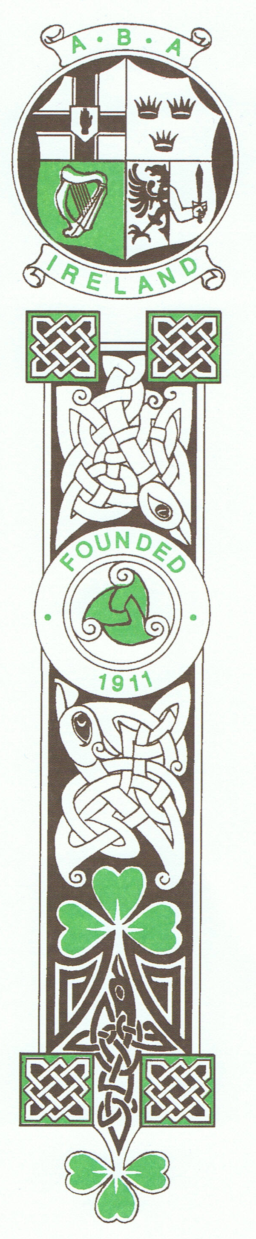

IRISH ATHLETIC BOXING ASSOCIATION
National Stadium 145 South Circular Road Dublin 8 D08HY40
Tel: +353 (1) 4533371 Email: info@iaba.ie Web: www.iaba.ie

To: Provincial Councils & County Boards
(Please distribute to ALL Clubs in your Unit immediately)

Men’s & Women’s National Senior Championships 2017

Dates: November 17th, 18th, 24th, 25th & December 1st & 2nd (If Required)

Venue: National Stadium, Dublin

Weigh Ins
Friday 17th 8.30am-10.00am 12.00- 1.00pm in the
Ringside Club National Stadium , 145 South Circular Road, Dublin.
Daily 8-9am

Draws 2.30 pm In the National Stadium

Age Requirements:

(Men & Women) Shall have reached the age of 18 years and be under 40 years of age on November 17th of this year and not have competed in the National Elite Championships and not have won a Provincial Elite Championship.
Boxing Friday 17th November 7pm
Saturday 18th 11am
Friday 24th 6.30pm
Saturday 25th 11am
Friday 1st 6.30pm
Saturday 2nd (If Required) Contingent on Entries

Women: 48kg / 51kg/ 54kg / 57kg / 60kg / 64kg / 69kg / 75kg / 81kg / 81+kg
Men: 49kg / 52kg / 56kg / 60kg / 64kg / 69kg / 75kg / 81kg / 91kg / 91+kg

Entries: Entries should be forwarded in writing to reach the undersigned by Wednesday November 15th. Only boxers for whom entries have been received by that date will be allowed box. Entries must specify Club, weight division and date of birth.
Boxing: Boxing will be over 3x3 minute rounds for men and women.
Medical Record Cards and entry fee of 20 Euros must be produced at the initial weigh in. Males must present themselves clean shaven. NO HEADGUARDS for all male boxers over 18 as per new AIBA Rules.
All competitors must advise details of any medication they are taking or have taken in the preceding 4 weeks. Anti Doping may be carried out at any stage of the competition.
Attention is called to the stipulation in the IABA Rule book that each boxer presented by his/her club shall be fit to box. This is the responsibility of the club.
It is a condition of entry that all competitors and officials have signed the Members Acknowledgement Form or will not be allowed to participate.
Non Pregnancy Declaration forms must be signed.
Attire: Boxers shall have one red and one blue vest. Coaches must wear track suits and runners at all sessions and endeavour to set a high standard of hygiene at all times in the corners. Boxers must not wear long sleeved shirts under vests. Hair must be tied back and swimming hats should be worn under headgear. No International vests are to be worn at National Championships
N.B. Red or Orange or Pink Gum Shields are strictly prohibited.
2 Coaches per Club allowed free entry with their boxers.
We request all to accept decisions in a sporting manner. Please lead by example. Aggression will not be tolerated at any time.

Yours Sincerely

Art O’Brien
Hon Secretary,
Irish Athletic Boxing Association

President Dominic O’Rourke Vice President Joe Hennigan, Hon Secretary Art O’Brien, Hon Treasurer Larry Morrison, Hon Registrar Stephen Connolly

