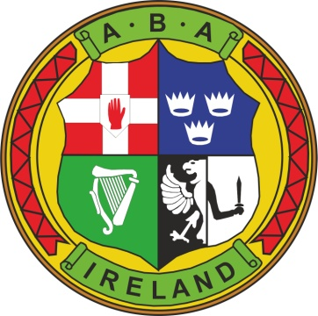IRISH ATHLETIC BOXING ASSOCIATION – CHILD SAFEGUARDING STATEMENT 2018
The IABA provides sporting activities and opportunities for young people though participation in clubs, national events and our national teams. The IABA is committed to safeguarding children and affiliated clubs work under the guidance of our Safeguarding Policies. All our volunteers and staff working with our young people, throughout the organisation, seek to create a safe environment for young people to participate in our activities.
This club’s written Safeguarding Risk Assessment document indicates the areas of potential risk of harm, the likelihood of the risk occurring, and gives the required policy, guidance or process documents required to help alleviate these risks. The list of risks identified is contained in the following categories: Club and Coaching Practices, Complaints & Discipline, Reporting Procedures, Use of Facilities, Recruitment, Communications and General Risk of Harm.

This club’s Child Safeguarding Statement has been developed in line with requirements under the Children First Act 2015, (the Children First: National Guidance and Tusla’s Child Safeguarding: A Guide for Policy, Procedure and Practice). In addition to our Risk Assessment document described above, there are further procedures that support our intention to safeguard children while they are availing of our activities.
The IABA has the following procedures in place as part of our Safeguarding Code and Policies:
- Procedures for the management of allegations of abuse or misconduct by staff or volunteers against a child availing of our activities
- Procedures for the safe recruitment of staff and volunteers to work with children in our activities
- Procedures for access to child safeguarding training and information, including the identification of the occurrence of harm
- Procedure for reporting of child protection or welfare concerns to Statutory Authorities
- Appointment of Designated Liaison Persons/Children’s Officers, Relevant Persons at Club and National level
The Mandated Person for the IABA is David Britton, Tel: 0860453904.
We recognise that implementation is an ongoing process. Our club is committed to the implementation of this Child Safeguarding Statement and the procedures that support our intention to keep children safe from harm while availing of our activities.
This Child Safeguarding Statement will be reviewed within 24 months of the date below.
Club name and address;
_____________________________________________________________________________________
Club Chairperson/President:

Name: Signed: Date:
_______________________________________________________________________________________
Club Children’s Officer (Relevant Person):

Name: Signed: Date:
_______________________________________________________________________________________

