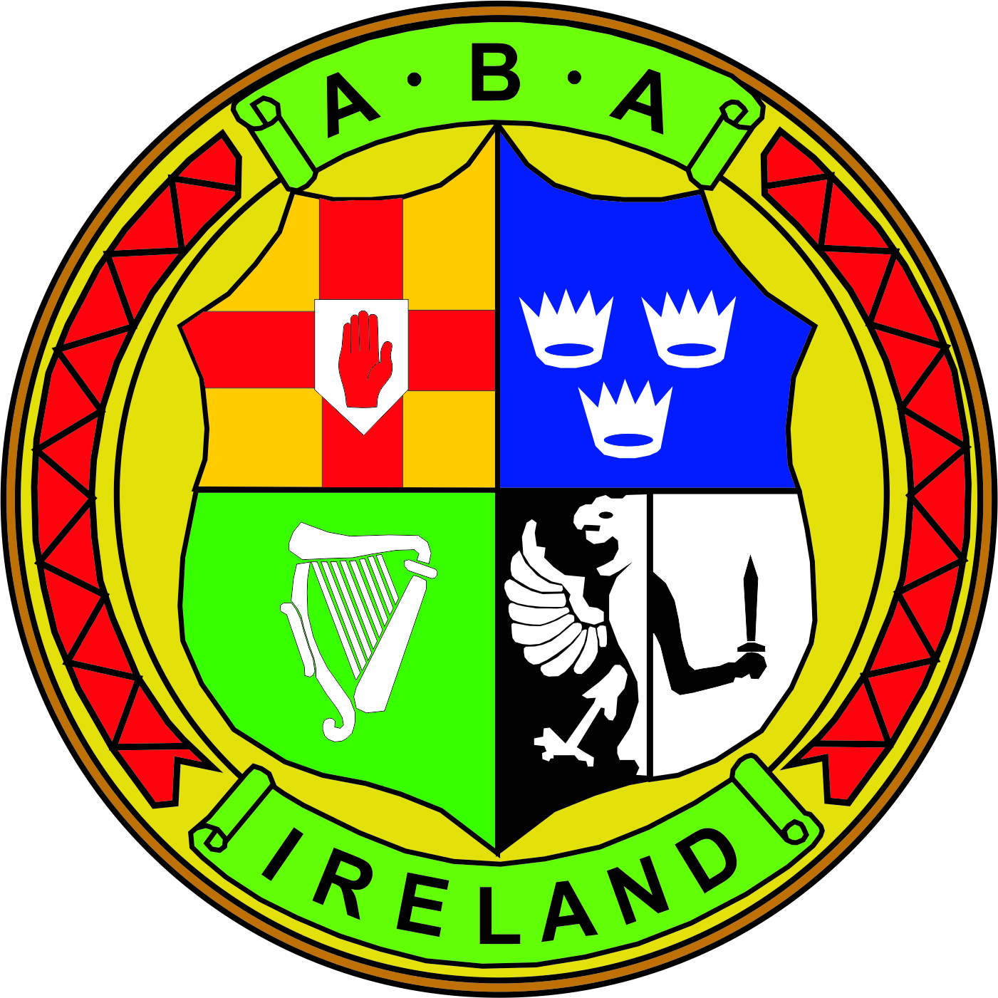 | IRISH ATHLETIC BOXING ASSOCIATION  Meeting Notes  BOARD OF DIRECTORS MEETING 05th DECEMBER 2017
 | Chairman: Joe Christle (JC)
Board: Dominic O’Rourke (DO), Des Fitzgerald (DF), Andrew Duncan (AD), Ciaran Kirwan (CK), Tom Geraghty(TG), Kevin Duffy (KD)
Company Secretary: John Nangle (JN)
Others: CEO Fergal Carruth (FC) Derek Reilly (DR)

Apologies : David Kearns (DK) , Garry O’Gorman (GO)
Chair’s Welcome | The Chair called the meeting to order and welcomed everyone, in particular the newly appointed directors who were attending the meeting for the first time. The board’s primary responsibility is one of stewardship ensuring that the IABA remains viable and effective in the present and for the future.  Round the table introductions then took place where each board member highlighted their own skillset, experience and what they could bring to this board.
ITEM 1 (Minutes) | Approval of the board of directors minutes 04th October 17. Proposed by DF, seconded KD.
ITEM 2  (Governance)  ITEM 3 (HR)  ITEM 4  (Child Protection)  ITEM 5  (R&J’s)  ITEM 6  (Deloitte Review)  ITEM 7  (Sub Committees)  ITEM 8  (Legal) | JC welcomed Derek Reilly from the Carmichael Centre who gave a presentation on the Governance Code and its five principles and that the minister of Sport is making this code mandatory for all sporting bodies in receipt of funding.  Hand outs were circulated on the roles and legal responsibilities of directors and discussions took place on fiduciary duties, conflicts of interest, board skill assessment, rotation and terms of office and how best practice this could be implemented in the best interest of boxing.  JN spoke briefly on the updated employee handbook which had been circulated to board members. The document had been reviewed by Graphite HRM and contained information on policies, standards, procedures including legislation and good practices in HRM. After discussions it was decided that board members should have a further review of the handbook and raise any comments prior to the next board meeting.  The update vetting policy and Children’s first legislation was agreed by the board. FC updated board members on Dublin Council Board and the vetting process.  JC brought to the attention of everyone that in Sept the treasurer undertook to bring a fair and equitable referees and judges expenses claim policy back to the board for review and this still remains outstanding. A reminder is to be send to the treasurer so that this can be put in place of the board at the next meeting.  JN gave an account of the Deloitte Governance and Financial  Administration audit and circulated the recommendations and key actions points that the IABA’s board needed to address. Funding would be curtailed or delayed if the IABA didn’t address the concerns raised by Deloitte. Four significant areas were raised.  - Directors fiduciary duties  - Non-compliance with Directors Code of Conduct  - Rulebook  - Good Governance practices in terms of tenure of office holders  A brief discussion took place on board sub-committees and how these work effectively and best serve the IABA and it was agreed that TG would join the HR and Nominations committee. It was agreed that the Governance and Rule Book sub committees would be amalgamated and that AD would join this committee.  CK brought to the board’s attention an urgent matter concerning fees outstanding to the IABA’s former solicitors for defencing an historical case a number of years ago. Negotiations on reaching a settlement took place reducing the fee by 50% payable in two instalments. It was agreed by the board that this should be accepted.  FC gave a brief update on the current case concerning the disputed rerun Ulster council election.
 | The meeting then concluded.

