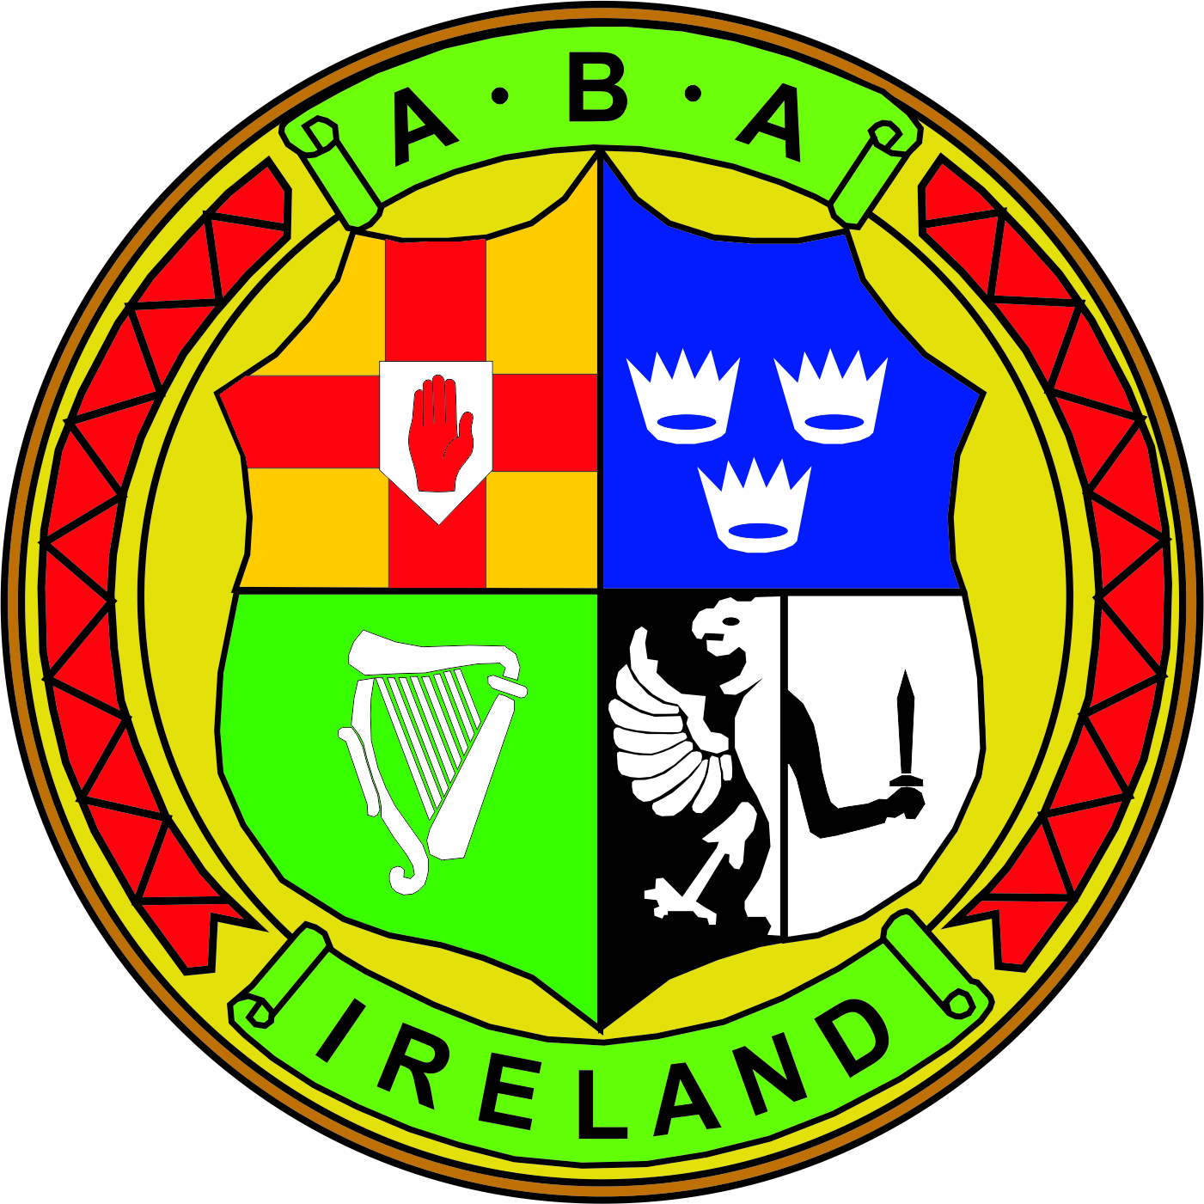 | MEETING NOTES  BOARD OF DIRECTORS MEETING  24th July 2018 National Stadium 6.30pm
(In Attendance) | Chairman: Joe Christle (JC)
Board: Dominic O’Rourke (DO), Des Fitzgerald (DF), Ciaran Kirwan (CK), Andrew Duncan (AD), Garry O’Gorman (GO), Tom Geraghty (TG) , David Kearnes (DK).

Company Secretary: John Nangle (JN)

Apologies : Kevin Duffy (KD)

Others: CEO Fergal Carruth (FC) Gerry O’Mahoney (GOM)
Chair’s Welcome | CK thanked everyone for making themselves available and declared the meeting open.
ITEM 1  (Minutes) | The minutes of the meeting held on the 11th April 2018 which had previously been circulated were approved. Proposed CK and Seconded by DK.
ITEM 2  (Regional Report) | FC introduced JD the IABA’s new workplace development officer, who circulated an overview of the Ulster operation and structure. That the main focus of her role was to provide a wide range of learning opportunities to ensure that the Ulster boxing community and volunteer workforce is well informed and provided with adequate training. In areas such as formal accredited coaching, judging, refereeing qualifications, Governance training in areas of health & safety, safeguarding, financial management, GDPR, committee roles and responsibilities.
ITEM 3 (MATTERS ARISING) | FC notified the following:  The Elite Championship 2019 would hopefully take place in Belfast with the assistance of Belfast City Council. Recent court matters in relation to the Commonwealth games has been resolved.  Following a number of meetings between Sport Ireland and the IABA’s liaison group in respect of the Deloitte action plan, confirmation received that funding restriction had been lifted.  After a recent meeting with Sport NI, their CEO is likely to bring a positive recommendation to their board in August to remove restrictions of funding in Ulster.  There has been an alleged anti-doping violation, this is currently under appeal.  The OCI has recently announced its funding allocation of €200,000 to national governing bodies. Boxing has been granted the maximum grant of €20,000. This supports our specific Olympic programme under the criteria and guidelines of the OCI.  New Staff – Jolene Donnelly has been appointed as the IABA’s workplace development officer for Ulster. James Geraghty recently took on the role of club development officer.  David Britton has been promoted to safeguarding and operations manager. Lisa Doyle is the new community employment supervisor.  The IABA has recently received a statement of claim which may result in significant legal expense to the IABA.  A discussion took place concerning CPG providers and Sport Ireland recommendations.  The CEO strongly recommend that it is clearly set out by the RB sub-committee for our clubs, County Boards, Provincial Councils and National Championships the exact level of medical supervision that is required at all levels of competition.  AIBA has set out its new foundation plan which had recently been circulated to board members.  A general board discussion took place on the need for appropriate qualified people at events, CPG approved licensed providers, health & safety, AIBA rules and the plans to improve the designated area for medical staff within the National Stadium in early course.  DO proposed that Kevin Morgan and Mick Gill would be on the newly formed affiliation review panel together with an independent legal professional. Agreed by all.
ITEM 4  (GDPR) | FC spoke about the report previously circulated to board members outlining the work that had been done to date, correspondence was sent to the clubs, committees and data champions have been put in place, insurance company concerns. Ultimately the IABA needs to move towards an online affiliation process making it easier and secure in order to mitigate the chances of any potential GDPR data breaches.  AD felt that perhaps in the long term the IABA will need to move to an online platform, but in the meantime more detail should be provided on what the actual insurance company stated. A general discussion took place and it was felt that more supporting information on this area should be circulated to board members as soon as possible. TG made reference to the information already provided to clubs feeling that it needed to be more descriptive better guidance given.
ITEM 5 (Governance) | DF gave a brief synopsis of the Rulebook subcommittee, good engagement and progress has been made, the committee is now entering the final phase reviewing the composite of the board of directors to include the majority as boxing participating people.  JC informed everyone that KD had step down from the Affiliations/Safeguarding and Governance sub committees due to work commitments. GO gave an account of the HR and Nominations sub-committee meeting and its minutes will be circulated to everyone prior to the next board meeting.  DO gave an account of the HPAC meetings, that matters are moving along slowly, hopefully information can start to flow.  A discussion took place regarding the HP Directors request that the Elite championship for 2019 be scheduled for November 19 to assist in preparation. DO reminded everyone that it was the collective decision of the Central Council to schedule the Elites for February which they had the right to do in accordance with the current rulebook. A general discussion took place on youth and junior boxing and the role of the HP Director in team selection.  JC advised of a matter surrounding a commonwealth team selection and the equality commission. As such it is important to have clear transparent team selection criteria to prevent similar cases occurring in the future.  JC reminded each of the sub-committee if they had a report on their activities if this could be forwarded to JN who will circulate this well in advance of the next board meeting.  JN circulated the recent referee and judge’s proposal from the treasurer, DO advised that this was under review and would be brought to the board in a future period.
 | The meeting then concluded.

