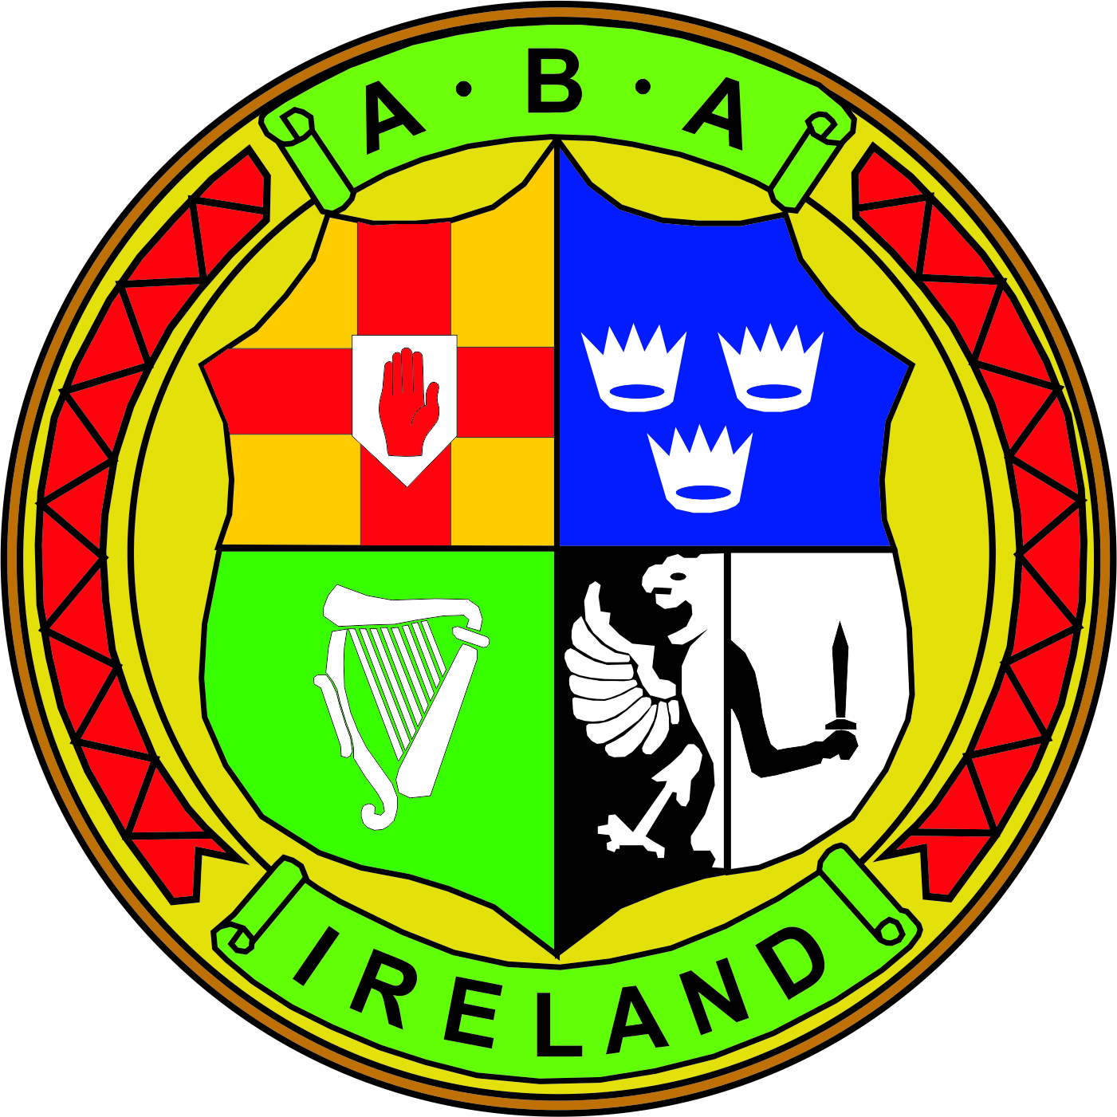 | MEETING NOTES  BOARD OF DIRECTORS MEETING  3rd October 2018 National Stadium 6.30pm
(In Attendance) | Chairman: Joe Christle (JC)
Board: Dominic O’Rourke (DO), Des Fitzgerald (DF), Andrew Duncan (AD), Garry O’Gorman (GO), Tom Geraghty (TG) , David Kearnes (DK)

Company Secretary: John Nangle (JN)

Apologies : Kevin Duffy (KD) , Ciaran Kirwan (CK)

Others: CEO Fergal Carruth (FC) Larry Morrison (LM)
Chair’s Welcome | JC declared the meeting open at 6.30pm and welcomed everyone.
Treasurer Proposal | JN circulated the treasurer’s proposal on referees and judges. LM gave an overview how he felt officials could be reimburse for 2019 and how the process would operate, as this year’s budget was already expended.  A discussion took place and it was agreed that the entire central council 2019 budget needed to be fully costed out and stuck to, with funds allocated for R&J expenses that overnight accommodation costs had risen at an alarming rate and a discussion would be required to address this whole area.  LM felt that his current budget was stretched and that additional funds were needed to operate effectively. He agreed to draft up his plan for 2019 prior to the next board of directors meeting.
Board Meeting  ITEM 1  (Minutes) | The minutes of the meeting held on the 5th September 2018 which had previously been circulated were approved. Proposed GO and Seconded by DK.
ITEM 1  (MATTERS ARISING) | JC gave an update on the draft rulebook that had been circulated to the board for review.  AD raised a concern surrounding the interpretation and wording of eligibility criteria to becoming a board member. A discussion took place and it was agreed that this section within the draft rule book be reworded and expanded to ensure clarity and avoid confusion. That the draft would not be distributed until reworded and available on the website after the Convention.  A discussion took place on the upcoming Convention in Cork and that any potential issues similar to 2017 should be avoided. It was agreed that a meeting would take place with the Munster president prior to the Convention.
ITEM 2 (GOVERNANCE) | FC advised that Deliotee would be carrying out a follow up pulse audit on the IABA in the comings weeks and that board members maybe ask to complete a questionnaire.  DF reminded board members that the IABA had to safeguard its funding streams and that good governance was important, it was not all down to rules, it is also about the ethical culture of the association and behaviour of individuals who govern. The IABA needs to be able to demonstrate transparency, accountability, responsibility with all stakeholders.  AD felt that a template needed to be developed to assist clubs with their Sport Capital Grant applications and that the IABA needed to look at obtaining additional funding.  GO proposed the Safeguarding implementation plan as circulated. Seconded DK.
ITEM 3  (FINANCE) | JN circulated financial update and a forecast of likely central council expenditure to December 2018.
 | The meeting then concluded.

