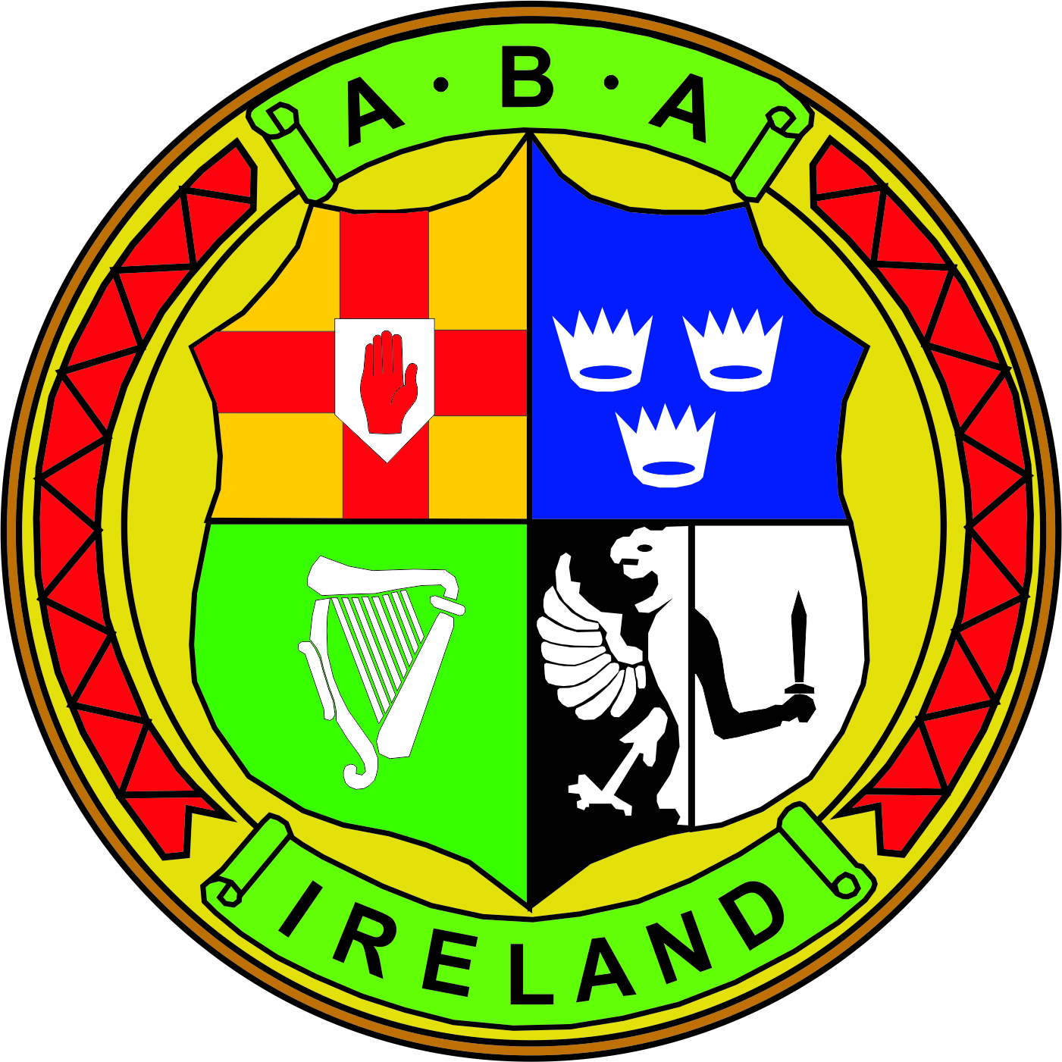 | MEETING NOTES  BOARD OF DIRECTORS MEETING  5th September 2018 National Stadium 6.30pm
(In Attendance) | Chairman: Joe Christle (JC)
Board: Dominic O’Rourke (DO), Des Fitzgerald (DF), Ciaran Kirwan (CK), Andrew Duncan (AD), Garry O’Gorman (GO), Tom Geraghty (TG) , David Kearnes (DK), Kevin Duffy (KD).

Company Secretary: John Nangle (JN)

Others: CEO Fergal Carruth (FC) Gerry O’Mahoney (GOM)
Mark Pringle (MP) David Britton (DB)
Chair’s Welcome | JC declared the meeting open at 6.30pm and welcomed members and guests.  JC reflected on the past 12 months the achievements and disappointments, acknowledging the importance of good governance and the various streams of Government funding received by the Association. The recent matter regarding youth team selection not only affects the boxers and coaches but also the reputation of the IABA and it needed to be resolved, calling on the HPAC committee and all related parties to meet and arrive at a solution.  DO welcomed this and gave a commitment to hold a meeting within the next seven days.
AGM | - Anti-Doping  FC circulated and read out the recently received Anti-Doping Report. There is a current ongoing boxer disciplinary hearing and that the IABA is bound by Sport Ireland rules in this area.  - Presentation of Auditors Report and Financial Statements  JN presented the annual financial statements and auditors report for the 2017 financial year, providing an overview of the income and expenditure of the period.  The AGM resolved to adopt the financial statements for year ended 2017 and reappoint BKRM as auditors for 2018. Proposed by DF and DK.  - Renewal of Licences  JC Notify members of the application to renew that National Stadium Public Singing and Dancing Licenses.  The AGM resolved to apply for a renewal of the existing licenses for a further 12 months. Proposed by JC seconded DF.  JC thanked everyone for their service to the board and thereafter declared the AGM closed.
Board Meeting  ITEM 1  (Minutes) | The minutes of the meeting held on the 24th July 2018 which had previously been circulated were approved. Proposed DK and Seconded by AD.
ITEM 1  (Insurance Update / GDPR) | JN introduced MP who provided an update on the IABA’s insurance policies and savings obtained that will be reflected in premiums next year to clubs. Certain insurers would not provide specific data / GDPR cover.  A general discussion took place on data management and insurance, in that several members of the association had access to personal data on their own personal machines, there is significant risk to directors personally for any data breach at club or county board as well as the company. As such directors must not neglect their responsibilities in terms of implementing strong data protection processes and policies otherwise there is exposure to risk and personal liability. The need for good housekeeping in terms of tidy desk policy, centralising affiliations, storing data securely with limited access. The onus was on the board of directors to assess how the IABA is in compliance with GDPR.  DB circulated the data processing activity report, and spoke briefly on the need for the IABA to review its data protection practices in light of the changes under GDPR. The report consisted of a GAP analysis on the IABA’s specific processing operations, it identified a number of actions that needed to be implemented.  In terms of the report the most likely exposure to a breach was the affiliation process. AD felt that other risks exist and that he had requested information in terms of what was required for sporting clubs in this area and will forward this on.  A general discussion took place and it was agreed that a board sub-committee be established to look more closely on this. Members GO, AD, TG.
ITEM 3 (MATTERS ARISING) | JC touched on the Board’s standing orders and order of business that had previously been circulated and if members had anything to add on the format could they please reply to the company secretary prior to the next board meeting, all agreed.  FC advised the board that a request had been received for the offices above the gym by the officer board and that a meeting is arranged with Stephen Connolly.
ITEM 4  (GOVERNANCE) | DK provided a brief report on the strategic plan illustrating the level of completion in the various segments.  GO gave an update on the Nominations and HR sub-committee, interesting discussions had taken place on gender and board composition, requesting the terms of reference be approved. Proposed CK Seconded DF.  FC circulated a copy of the draft maternity policy. Approved by the board.  DF spoke on the ongoing work of the Rulebook sub-committee and hoped that the process will accelerate in the coming weeks. He acknowledged the contribution and complemented on the work in this area by FC and JN in satisfying Deloittee, Sport Ireland and Sport NI.
 | The meeting then concluded.

