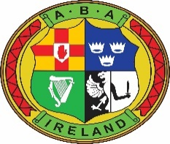

Women in Sport Coaching & Mentoring Programme

To apply for this Leadership Programme, you must be an Irish Athletic Boxing Association Member.
Name:
Club:
Please describe in 200 words why you would like to complete this programme?
Please include information regarding your current and/or previous leadership roles, including the length of time in the role, key learnings and aspirations for your future within the sport.

Applications Date: Monday August 10th at 5pm
Please return via email to:
James Geraghty
james@iaba.ie

