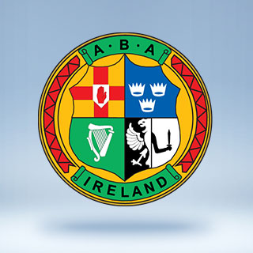
IABA Youth National team
(Home sessions)

S&C Session

Circuit – 4 Sets ( 30 seconds each exercise, 5 second break, all body weight only )

Lunges

Press ups

Tuck Jumps

Sit Ups

Squats

Plank

Leg Raises up n down

Ankle Grabs

