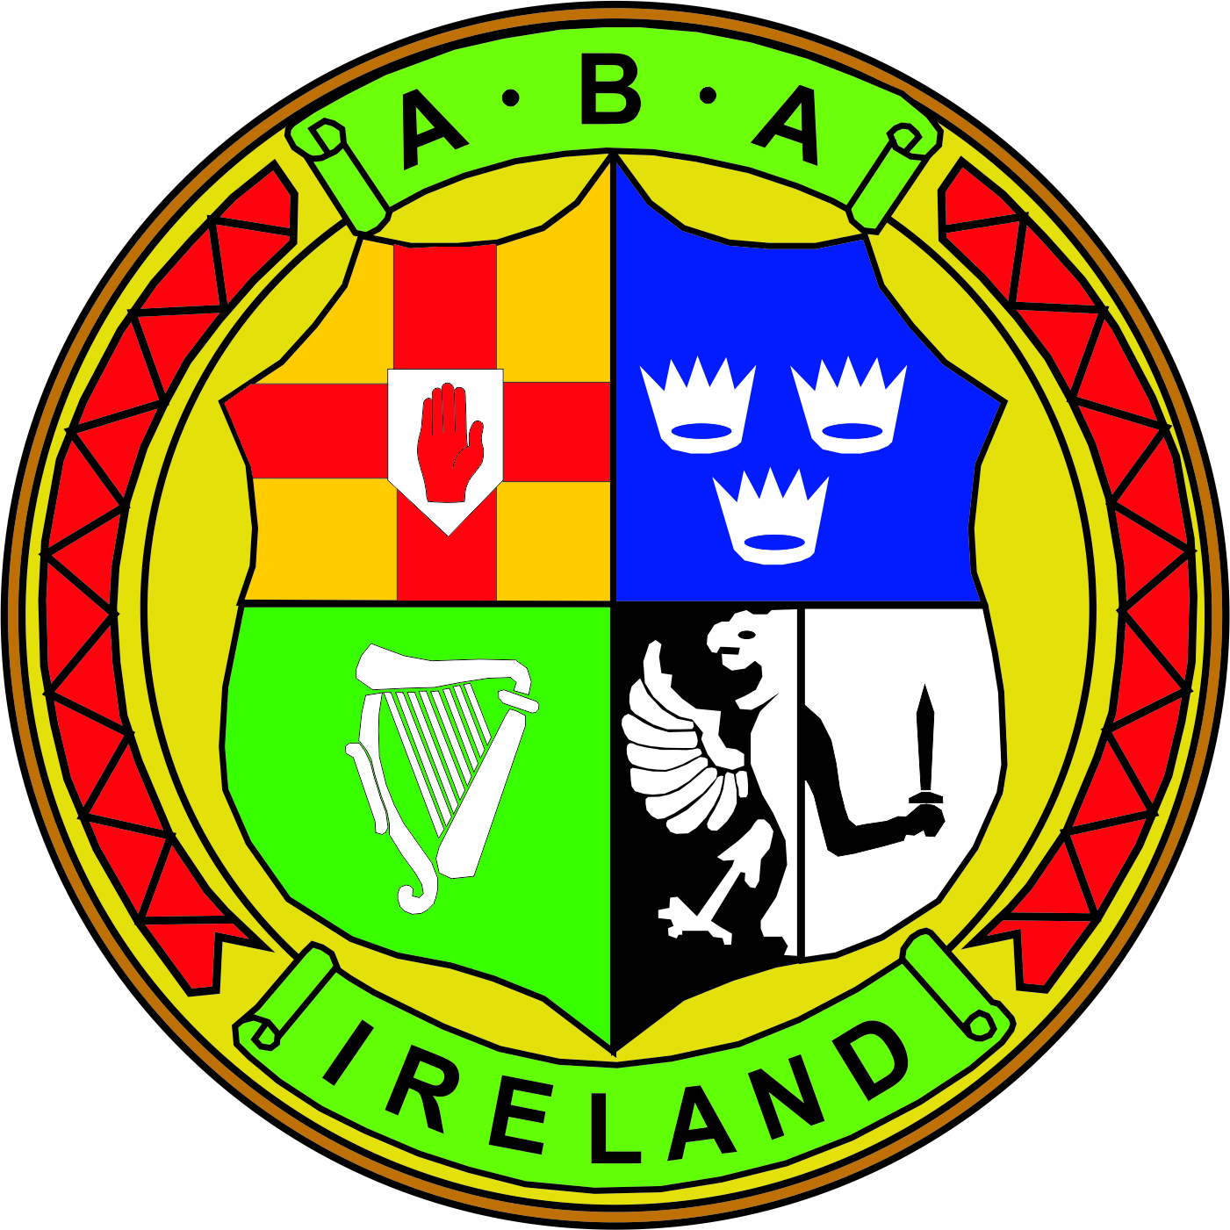 | IRISH ATHLETIC BOXING ASSOCIATION  Meeting Notes  BOARD OF DIRECTORS MEETING 07th February 2018
 | Chair: Joe Christle (JC)
Board: Dominic O’Rourke (DO), Des Fitzgerald (DF), Andrew Duncan (AD), Ciaran Kirwan (CK), Tom Geraghty(TG), Garry O’Gorman (GO), David Kearns (DK).
Company Secretary: John Nangle (JN)
Others: CEO Fergal Carruth (FC) Bernard Dunne (BD)

Apologies : Kevin Duffy (KD)
Welcome & Introductions | The Chair called the meeting to order and welcomed all attendees. DK and GO gave brief introductions highlighting their skills and experience.
ITEM 1 (Minutes) | Minutes of the last meeting 05th December 17, reviewed, considered and approved. Proposed by CK, seconded AD.
ITEM 2  (High Performance)  ITEM 3 (Strategy)  ITEM 4  (AIBA Dubai)  ITEM 5  (Legal)  ITEM 6  (Stadium)  ITEM 7  (Notifications)  ITEM 8  (Governance) | JC welcomed BD who outlined his plan for 2018 noting high performances obligation to meet it principle responsibilities in an efficient and effective manner using funding wisely. The level of funding committed by Sport Ireland remains the same with the focus for the year ahead geared towards the European and Worlds competitions, identifying talent, coach development and high performance education. Collaborating with the US and elites in March, training camps and the June round robin tournament were discussed.  DK provided a progress report on the strategic plan outlining and highlighting all objectives and areas to emphasise for the future. A discussion took place on evaluating the plan.  FC read out a report on activities at the extra-ordinary AIBA congress 26th January 18. Matters concerning AIBA financial affairs and governance were highlighted and that the longest severing vice president of AIBA has been appointed as the new interim president.  FC updated the board on developments since the last meeting and responded to issued raised by board members.  FC advised the board that the IABA has been awarded department capital grants which will assist in the refurbishment of the National Stadium. Security, Health and Safety, charge out rates for fair use of the stadium and sponsorship were touched on.  JN advised all that the IABA received funding from Sport Ireland to obtain a graduate on an 11 months basis and that recruitment was under way. A CE supervisor will be appointed in due course, Pat Costello is assisting the CEO with securing sponsorship and it was agreed by the board that DO would be appointed as the board representative on the HP Advisory Board.  A policy to appoint members to a disciplinary panel was approved by the board of directors. It was agreed that this disciplinary panel be established to provide for a mechanism for resolving complaints. The panel would be made up at least three members of the central council, at least four members of the panel would come from an independent legal background and at three other members of the panel would be members of the IABA but not on the central council. Three members including a Chair was agreed by the board in relation to the legal profession of these members.  JC outline the process so as to move the rule book, memorandum and articles of association forward and it was agreed that a timeline and effective communication plan was needed to accelerate this process with the involvement of all stakeholders. Invitations will go to all members to attend a schedule of meeting over the coming weeks.  It was agreed that legal advice was needed with regards a matter in respect of the issue concerning the garda vetting process and Dublin County Board.
 | The meeting then concluded.

